

**FELLOWSHIP**

**“Information and Membership Package”**

**Apostle Dr. Gregory Sherman, Founder**

**(678) 663-7346**

**GATE KEEPERS FELLOWSHIP**

**CONTENT PAGE**

**Gate Keepers Fellowship… Pages**

Scripture, Definition, Mission and Theme p.3

Five-Fold Purpose p.3

Leaders and Members p.4

Executive Council, Overseers & Regional Overseers p.5

Important Dates in 2020 p.5

Conference Calls p.5

What We Believe p.6

Membership, Cost, Benefits and Opportunities to Fellowship p.7

About the Founder p.8

About the 1st Assistant p.9

About the 2nd Assistant p.10

About the 3rd Assistant p.11

Executive Overseer p.12

Executive Secretary p.13

The Gate Keepers Pastors & Overseers p.14

Enrollment Form p.15

**GATE KEEPERS FELLOWSHIP**

**“WHO WE ARE”**

*All these which were chosen to be porters in the gates were two hundred and twelve. These were reckoned by their genealogy in their villages, whom David and Samuel the seer did ordain in their set office. So they and their children had the oversight of the gates of the house of the Lord, namely, the house of the tabernacle, by wards. I Chronicles 9:22-23*

**Gate Keepers Definition:** A Guard Appointed to Protect the Gates of the City or the Temple.

**Mission:** To Bring Reformation To The Church.

**Theme:** “Doing More Together”

**Official Launch Date:** Sunday, February 9, 2020 @ 3:30 PM

**Purpose / Vision:** The Gate-Keepers Fellowship is birthed out with a Five-Fold Kingdom Purpose.

1. **Emphasis** **of the Reformation**: Returning back to the original design, purpose and intent of the Church of Jesus Christ with Emphasis on Demonstration of the Supernatural Power of God, through Miracles, Signs and Wonders, and the Manifestation of God’s Favor that will bring about a harvest of souls and strengthen believers to walk in their Christian discipleship and spiritual maturity.
2. **Training for all Tiers of Leadership:** To help provide Pastors with available training for all tiers of leadership for churches involved in the fellowship. Which in turn will help strengthen churches with their Vision.
3. **Encouragement and Fellowship for Pastors and Leaders**: To connect with other kingdom minded pastors and continue to do the work of the Kingdom.
4. **Financial Economic Empowerment**: Helping provide financial empowerment strategies, knowledge and skills to make accurate consumer decisions to empower believers to achieve economic well-being.
5. **Men and Young Men**: To help strengthen and encourage men and provide solutions to a rising problem among our young men. Helping more of our men and young men stay focus. Providing the support they need to think about their future and what they need to do to be successful in life.

**NOTE**: The Gate Keepers Fellowship (GKF) is **NOT** a denomination or religious organization. The Gate Keepers Fellowship, embraces all pastors, churches and leaders who accept Jesus Christ as Savior and Lord, and who acknowledge and accept the gifts of the Holy Spirit. We believe in the autonomy of the Church and respect it as such. Pastors who are members of the Gate Keepers Fellowship do not have to leave their spiritual covering or any other Fellowship they may presently be members of. The Gate-Keepers Pastors accept and respect each other as Colleagues in the Gospel of Jesus Christ.

**GATE KEEPERS FELLOWSHIP**

**“LEADERS AND MEMBERS”**

**The Gate Keepers Fellowship Consist of the Following Leaders and Members:**

1. **The Executive Council:** The Executive Council Members are comprised of the Founder, First Assistant, Second Assistant, Third Assistant, Executive Overseer, Executive Secretary, Executive Treasurer and Overseer of Regional Pastors.
2. **The Overseers Council:** Overseer Council Members are comprised of experienced, seasoned, anointed, trusted colleagues of Apostles, Bishops and Pastors who will undergird the fellowship, serve as an Overseer for the Fellowship, as well as, assist in Leadership Training for the Fellowship.

The Overseer Council will provide support for **Consecration and Installation** Services of Pastors who are being consecrated into the office of an Apostle or Bishop, who meet the qualification and who are approved by the Gate-Keepers Overseer Council.

The Overseer Council will provide support for Consecration and Installation Services of Elders and Ministers into the office of a Pastor, who meet the qualifications and who are approved by the Gate-Keepers Advisory Council.

1. **The Regional Overseers** – Pastors who are located in different states and or regions who are serving as a State or Regional Overseers in the Gate Keepers Fellowship.
2. **The Pastoral Members** – are comprised of Senior Pastors who previously or presently overseeing a flock.
3. **The Leadership Support Team Members** – are comprised of Elders, Ministers Evangelist, Deacons and Leaders who are under the covering of a Gate Keepers Pastor or who were recommended by his or her pastoral covering.
4. **Gate Keepers Fellowship Delegates** – are comprised of members who are under the covering of a Gate Keepers Pastor or who were recommended by his or her pastoral covering to attend the Training.

**Gate Keepers Fellowship Executive Council Members:**

1. Apostle Gregory Sherman Presiding Apostle / Founder
2. Apostle Robert Miller 1st Assistant to Presider
3. Bishop A.B. Sermon 2nd Assistant to Presider
4. Pastor Craig McAshan 3rd Assistant to Presider
5. Dr. Glenda Sherman Executive Overseer
6. Pastor Rita Davis Executive Secretary
7. Pastor Darlene McAshan Executive Treasurer

**The Gate Keepers Fellowship Overseer Positions:**

1. Overseer of Christian Education
2. Overseer of Community Action & Development
3. Overseer of Evangelism
4. Overseer of Financial Empowerment
5. Overseer of Foreign Missions
6. Overseer of Helps & Protocol
7. Overseer of Intercession
8. Overseer of Marketing
9. Overseer of Men
10. Overseer of New Regions
11. Overseer of Praise Dance
12. Overseer of The Oil of Joy
13. Overseer of Worship & Music
14. Overseer of Young Men

**The Gate Keepers Fellowship Regional Overseers**

1. Georgia Regions
2. Florida Regions
3. South Carolina Regions
4. Connecticut, Regions
5. International Regions
6. Others TBA

**Gate Keepers Fellowship - Monthly Conference Call Meetings:**

1. Executive Council Conference Call Monthly Meetings Every 1st Monday @ 7:30 PM
2. Empowerment Conference Call Monthly Meetings Every 4th Saturday @ 12 PM

(For All GKF Apostles, Bishops, Overseers & Pastors)

**Conference Call #: 774-220-4000**

**Access Code: 35557**

**GATE KEEPERS FELLOWSHIP**

**“WHAT WE BELIEVE”**

**We believe** the Bible, the Scriptures, both Old and New Testaments, are the inspired Word of God without error.

**We believe** there is one God, Creator of all things, infinitely perfect, and eternally existing in three manifestations: Father, Son and Holy spirit.

**We believe** Jesus Christ is the true God and true man, having been conceived of the Holy Spirit and born of the Virgin Mary. He died on the cross for our sins according to the Scriptures. He arose boldly from the dead, ascended into heaven, where he now sits at the right hand of the Father, who is now our Hight Priest and Advocate.

**We believe** the ministry of the Holy Spirit is to glorify the Lord Jesus Christ and during this age, to convict men of sin, regenerate the believing sinner, indwell, guide, instruct, and empower the believer for godly living and service.

**We believe** there will be a bodily resurrection of all the dead; of the believer to everlasting blessedness and joy with the Lord, and of the unbeliever to judgment and everlasting damnation to hell.

**We believe** water baptism by immersion soon after accepting Christ as personal Savior, is a testimony of death to sin and resurrection to a new life.

**We believe** the Lord’s Supper is a memorial service setting forth in sacred and symbolic manner the death of the Lord Jesus Christ; all true believers and only believers should share in it.

**We believe** God’s design for sexual intimacy is to be expressed only within the context of marriage between one man and one woman as the foundation of the family and the basic structure of human society. For this reason, we believe that marriage is exclusively the union of one man and one woman.

**We believe** that God created all human beings in His image. Therefore, we believe that human life is sacred from conception to its natural end; that we must honor the physical and spiritual needs of all people; following Christ’s example, we believe that every person should be treated with love dignity and respect.

**GATE KEEPERS FELLOWSHIP**

**MEMBERSHIP**

**Who Can Join the Gate Keepers Fellowship?**

You must be an Apostle, Bishop, Pastor, Prophet or Evangelist to enroll in the Gate-Keepers Fellowship. Pastors can enroll their Leaders to participate in quarterly trainings.

Complete the GKF Enrollment Form.

1. **Annual Membership Cost:** The annual membership fee for the Gate Keepers Fellowship is **$100** for Apostles, Bishops and Pastors. No Annual Membership Fee for Church Leaders and Delegates.
2. **The GKF Membership includes the following:**

* Fellowship Lapel Pin
* Fellowship Official Logo Seal
* Free Access to GKF Trainings
* Materials and Handbook
* VIP Seating

**Benefits for GKF Council Members**

1. Colleagues Supporting One Another at Special Events
2. Spiritual Strengthening
3. Encouraging One Another
4. Praying for One Another
5. Leadership Training Available for Church Leaders
6. Strategies on How to Make a Difference in the City
7. Kingdom Business Connections
8. Social and Civic Action Partnerships
9. Financial Blessings

**GKF Opportunities for Fellowship**

* 1. Monthly Online Pastor's 30-45 Minutes Empowerment Call
  2. Six Months Pastor's Iron Sharpens Iron Fellowship Luncheon
  3. Annual Leadership Training for Leaders
  4. Gate Keepers Local Support for Colleagues
  5. Gate Keepers Regional Fellowships
  6. Gate Keepers Annual Fellowship Convention

**GATE KEEPERS FELLOWSHIP**

**FOUNDER**

**Apostle Dr. Gregory Sherman**

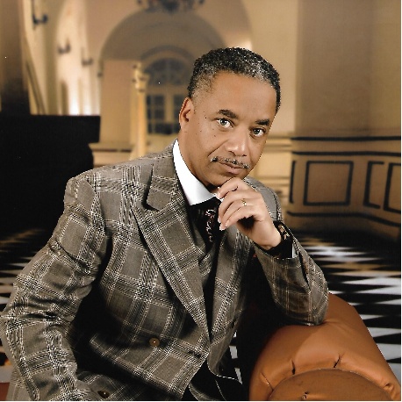

**Apostle Gregory Sherman**is the Founder of Shekinah Glory Tabernacle in Decatur, Georgia where he presently serves as senior pastor along with his wife Dr. Glenda Sherman who serves as Co-Pastor. The church was birthed out in October of 2002.

**Apostle Sherman** is a former graduate of South Carolina State University with a Bachelor's Degree in Business Administration. He received a Masters & Doctorate Degree in Religious Philosophy from Tabernacle Bible College & Seminary, Tampa, Florida.

**Apostle Sherman** has always inspired to be a leader from his young years. He started out as the President of the Student Christian Association at South Carolina State University; to the Minister of Christian Education and Assistant Pastor at the Greater Faith Church, Orangeburg, South Carolina; to the Pastor of two former churches to the founder of Shekinah Glory Tabernacle Praise and Worship Center where he presently serves as Senior Pastor.

**Apostle Sherman** was licensed and ordained as a preacher of the gospel at Greater Faith Church in Orangeburg, South Carolina by his spiritual mentor and father the late Dr. NLA Griffin. He served faithfully under his spiritual mentor for 15 years. He has been serving in Ministry for over 35 years.

**Apostle Sherman**is a teacher, preacher, trainer, spiritual mentor, and spiritual covering for many. His passion is reaching out to save the lost for Jesus Christ and discipling them. He is also committed to going beyond the four walls of the church and reaching out to the community through outreach and evangelism programs he sponsors every year for the community.

**Apostle Sherman** operates in the five-fold ministry gifts as Apostle, Prophet, Pastor, Evangelist and Teacher. He presently oversees and covers several local Pastors. He spends countless hours in properly training and counseling Pastors, Elders, Ministers and Deacons before releasing them to serve in their proper office and over the people.

**Apostle  Sherman** is a dedicated husband and father of four wonderful children, Gregory Karlton, Grace Shari, Gleshaun Kendrell, Glorhea Shekinah, and the grandfather to one beautiful granddaughter Joy Shari. To God Be the Glory!

**Apostle Sherman**, is the Founder of the Gate Keepers Fellowship because he believes that as Apostles, Bishops and Pastors in the Region, we can - Do More Together.

**GATE KEEPERS FELLOWSHIP**

**1ST Assistant to Founder**

**Apostle Robert L. Miller, Jr.**

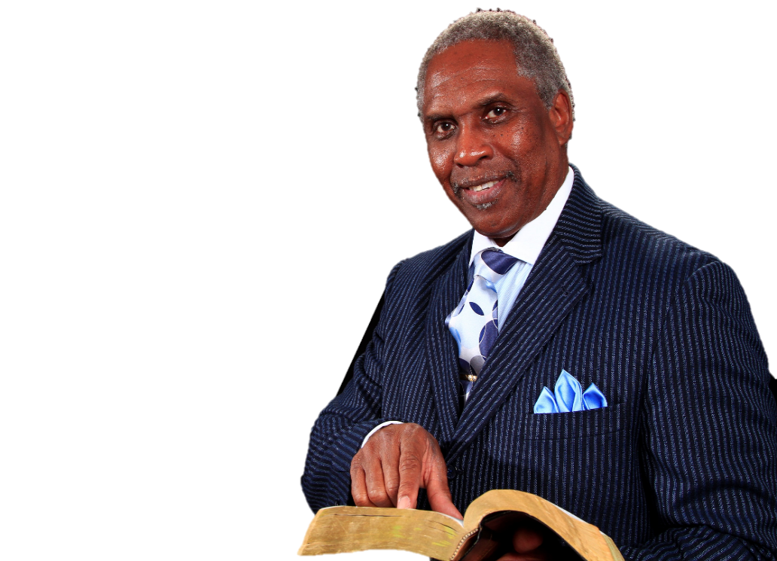

**Apostle Robert L. Miller Jr**., is a genuine and passionate man of integrity, who has a tremendous desire to transform the lives of God’s people and witness their walk in the supernatural power of God.

**Apostle Miller** is a graduate of George Washington Carver High School in Memphis, Tennessee, ranking third in a class of 380 students. He is a graduate of the University of Southern California where he earned a four (4) year athletic scholarship and played on the *Fighting Trojans Football Team*. He has also completed coursework toward a Masters of Divinity at Mercer University McAfee School of Theology in Atlanta.

**Apostle Miller** was ordained as a minister of the gospel of Jesus Christ in 1997 at Peace Baptist Church, Decatur, Georgia, where he served as Assistant Pastor under Pastor Tyrone Barnette for seven years. For the last eighteen years, Apostle Miller has served as the Senior Pastor of Trinity Worship in Ellenwood, Georgia. In October of 2018 the pastoral leadership baton was pass-on to his son, Robert L. Miller III.

**Apostle Miller** delights in Kingdom building and has been actively involved in helping to start 3 churches in the metro Atlanta area. His compassion for the loss is constantly displayed through participation in various outreach and evangelistic events where thousands have been led to accept the gospel of Jesus Christ. Such opportunities have included Crossover Atlanta, Crossover Columbus and missionary work in Brazil, where he assisted in the construction of five (5) churches and more than 1200 souls were saved.

**Apostle Miller** operates in the five-fold ministry gifts and is a Spiritual Father to many. He has licensed and ordained numerous deacons, ministers and elders, as well as adopted churches in Georgia, Virginia and Tennessee. The first church plant under Apostle Miller was launched in 2018.

***Apostle Miller*** is a former employee of Allstate Insurance Company where he served as a Senior Claims Analyst for 25 years. His wife of 46 years, the former Barbara Ann Williams of Memphis, Tennessee, faithfully serves by his side. They are the proud parents of three children, and seven grandchildren all who also serve in ministry.

**GATE KEEPERS FELLOWSHIP**

**2nd Assistant to Founder**

**Bishop AL. B. Sermon**

**Bishop Al B. Sermon** is the Founding Pastor of Word Reaching Destiny Ministries.  A proud native of West Palm Beach, Florida, he has been a minister of the gospel for over 20 years.  Bishop Sermon was ordained by Dr. William L. Sheals, Hopewell Baptist Church, Norcross, GA.  In February 1999, Bishop Sermon became the Sr. Pastor of Macedonia Baptist Church, Conyers, GA, under his leadership the congregation grew from 61 members to 530+ members over a three year span.  Under the guidance of the Holy Spirit Bishop Sermon birthed Nothing But The Word Christian Church/Word Reaching Destiny Ministries in Conyers, GA,   that  under  his leadership and the Grace Of The Almighty God Grew  from 0 to 373 members in 13 months then continued in a three year period to over a 1200 congregation.

He is an author of theological books and training manuals, as well as a sought after professor.   For three years, he taught at Hopewell Bible Institute, resulting in the creation of the Conyers, GA satellite location where he served as the Chancellor of the school.  In addition to being a teacher of the Word of God, Bishop Sermon is an overseer of eight churches and serves as the spiritual advisor/leadership trainer for multiple Pastors.

Bishop Sermon Has Received  Several  Awards  And  On  December  18th 2016.. Bishop Sermon Was Awarded   “THE PRESIDENT’S LIFETIME ACHIEVEMENT AWARD”   From   President Barack Obama.

Bishop Sermon is a teacher, preacher, and encourager that firmly believe that God is real, the Holy Spirit is our Comforter, and Jesus Christ is our Lord and Savior.  Bishop Sermon says the time has come for us to put down our personal agenda and focus on God's agenda, for not my will, but my Father's will be done.

Bishop Sermon is the proud father of three children: April, Joshua and Crystal Dominique.

**GATE KEEPERS FELLOWSHIP**

**3rd Assistant to Founder**

Pastor Craig McAshan

Bio Coming Soon!

**GATE KEEPERS FELLOWSHIP**

**Executive Overseer**

*Dr. Glenda Sherman*

**Dr. Glenda Sherman**, is married to Apostle Gregory Sherman who is the founder and Sr. Pastor of Shekinah Glory Tabernacle Praise and Worship Center in Decatur, Georgia. They have been married for 35 blessed years. She serves faithfully alongside her husband as Pastor and Co-laborer in spreading the gospel of Jesus Christ. She is an anointed woman of God who has accepted the higher calling of God on her life.

She was called and licensed as an evangelist of the gospel of Jesus Christ in 2001 and ordained as an Elder in March of 2010. Her academic pursuits include a B.A. Degree in Consumer Science, Masters Degree in Counseling Education, a Doctorate Degree in Religious Philosophy. She is an Author of the book entitled "What Time Is It". She is the host of the "Live Impartation" a weekly broadcast on Facebook Live. She served as an educator and counselor in the public school system for approximately 20 years. Presently, she is the Founder and Overseer of the SGT Christian Academy for children ages Preschool 3 & 4 years old to Elementary School 1st-6th Grade. She is definitely a role model for combining ministry, work, and home as wife, mother and grandmother.

**Her Calling**: Understanding that her passion and calling is to women of all ages and all backgrounds, she strives to help encourage, strengthen, and motivate women to walk in their divine calling and fulfill their God-given purpose. Therefore, she is the founder of several ministries to help aid in ministering to women of all ages and backgrounds:

**Her Purpose**: She believes as God appointed Esther for such a time as He did, to help bring deliverance to the Jews, she believes that God has anointed and appointed her for such a time as this to help bring salvation, deliverance, healing, and wholeness to women all across this nation and abroad.

**Her Mission**: Is to teach, preach and reach women from all walks of life through the different ministries God has allowed her to birth out. Her entire team is committed to helping meet those needs. We welcome the opportunity to minister to you through one of these powerful ministries:

**Her Family**: Dr. Glenda and her husband Dr. Gregory Sherman have been blessed with four lovely children, Gregory Karlton, Grace Shari’, Gleshaun Kendrell and Glorhea Shekinah, one granddaughter, Joy Shari’, and she is also blessed to have her mother Elder Willie Mae Hilton who serves faithfully alongside her and her husband in ministry. To God Be the Glory!!!

**GATE KEEPERS FELLOWSHIP**

**Executive Secretary**

*Pastor Rita Davis*

*Matthew 25:23 - His lord said unto him, Well done, good and faithful servant;*

*thou has been faithful over a few things, I will make thee ruler over many things:*

*enter thou into the joy of the lord.*

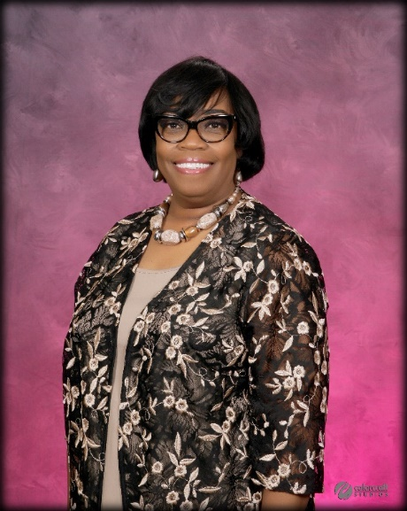

Pastor Rita Davis is the Founder of Life in the Word Prophetic Ministries and Rita Davis Ministries International

Pastor Davis was born and raised in Georgia. She is the oldest of 3 children and she has one son. She received Christ as her Lord and Savior when she was 12 and rededicated her life back to Christ in 1984, when she was 22 years old.

As a young woman she started having visions and dreams that would come to pass regarding people and situations. Some years ago, God revealed to her through a dream that she would someday pastor and be a prophet. This was confirmed by various other people and by an increasing desire to speak into people lives and to teach, guide and help others find their God appointed purpose in life.

She has held many positions in the church including Assistant Pastor and Christian Education Director, Youth Dept Leader & Secretary, and Leader of Church Intercessors.

Pastor Davis served faithfully as Assistant Pastor to Overseer Brenda Jefferson at New Life Christ Centered Ministries for 7 years. When Pastor Davis started as Assistant Pastor, she was told by Overseer Jefferson that she would learn all aspects of pastoring. Pastor Jefferson taught her and imparted into her all she knew as a pastor. Pastor Davis received a great wealth of knowledge and wisdom from Overseer Jefferson.

Pastor Davis is the founder of Rita Davis Ministries International and pastor of Life in the Word Prophetic Ministries which started January 6th, 2013 in her home.

She attended Shekinah Glory Tabernacle Bible Institute from Sept 2014 to 2018 and took several counseling courses from American Association of Christian Counseling,

She loves to teach and see people grow, be healed, delivered, and walk in their calling.

Her greatest desire is to hear God say, “Well done my good and faithful servant.”

**GATE KEEPERS FELLOWSHIP**

**OVERSEERS AND PASTORS**

**APOSTLE GREGORY SHERMAN**

Founder & Executive Overseer

**APOSTLE ROBERT MILLER, JR**.

1st Assistant

Overseer of Evangelism

**BISHOP AB SERMON**

2nd Assistant

Overseer of Christian Education & Florida Region

**PASTOR CRAIG MCASHAN**

3rd Assistant

Overseer for Loganville & Snellville Area

**BISHOP G.T. LEWIS**

Overseer for Regional Overseers

**DR. GLENDA SHERMAN**

Executive Overseer

**PASTOR RITA DAVIS**

Executive Secretary

**PASTOR DARLENE MCASHAN**

Executive Treasure

**PASTOR DAVID MCCLURE**

Regional Overseer of Connecticut

**APOSTLE ARJAE MATTHEWS**

Overseer of Worship

**PROPHET KESTER MATHIESON**

Overseer of Intercession

**TBA**

Overseer of Marketing

**APOSTLE LEWIS JONES**

Overseer of Foreign Mission

**PASTOR TRACY PITTS**

Overseer of Young Men and Liaison for Nigeria Men

**BISHOP CARL MCRAE**

Overseer of Social Development

**PASTOR KEITH & PAM ROZIER**

Overseer of Healthy Marriages

**PASTOR PERRY SCOTT**

Overseer of Men’s Ministry

**PASTOR JUSTIN CANNON**

1st Assistant to Men’s Ministry Overseer

**PASTOR JIMMY HALL**

3rd Assistant to Overseer of Men

**APOSTLE DUANE ELLIS**

Overseer of Conyers & Covington, GA

**PASTOR CHARLES OWENS**

Overseer of Helps Ministry

**PASTOR MARY JEFFRIES**

Overseer of Oil of Joy Ministry

**ELDER TAMMY SYLVESTER**

Overseer of Dance Ministry

**APOSTLE DARELL LOWE**

1st Asst. to Overseer of Helps Ministry

**DR. CALVIN ELLISON**

Overseer of Health and Wellness

**BISHOP ROGER CLARK**

GKF Pastor, Orlando Florida Region

**PASTOR JOHNNY & PATRICIA JENKINS**

Overseer of Pamplico & Florence SC Region

**ELDER SANDRAL SMITH**

1st Assistant to Executive Secretary

**PASTOR WANZO WALLACE**

GKF Pastor

**PASTOR JAMES KILGORE**

GKF Pastor

**GATE KEEPERS FELLOWSHIP**

**ENROLLMENT FORM**

**Please Complete Enrollment Form and Email to:**

[**gsherman.gatekeepers@gmail.com**](mailto:gsherman.gatekeepers@gmail.com)

**(678) 663-7346**

**Title** (Check One)

* **Apostle**
* **Bishop**
* **Pastor**

**Name:** _____________________________________________ **DOB** ______________

**Spouse Name** *(If Applicable)* ______________________________________________

**City:** _____________________________ **State:**___________ **Zip**: ____________

**Phone #:** ____________________ **Email:** ___________________________________

**---------------------------------------------------------------------------------------------------------------------**

**Name of Current Church/Ministry:** ________________________________________

**Number of Years Serving as a Pastor**: _____________________________________

**Address:** _____________________________________________________________

**City/State/ Zip:** _________________________________________________________

**Administrator’s Name** *(If Applicable)* _______________________________________

**Phone #:** ___________________ **Email:** ____________________________________

**---------------------------------------------------------------------------------------------------------------------**

**Please Answer the following Questions:**

1. Are you presently serving as a spiritual covering for other Pastors? ___________
2. Are you presently serving in another Fellowship or Alliance? ________________
3. If So, Name of Alliance (optional) _____________________________________

**---------------------------------------------------------------------------------------------------------------------**

**Ways to Pay Enrollment Fee: (Check One)**

1. _____**Make Check Payable To**: Gate Keepers Fellowship:

**Mail To**: 6087 Covington Hwy, Stonecrest, GA 30035

1. _____**Cash App**: $gkfellowship
2. _____**Paypal**: Go to [www.gatekeepersfellowship.org](http://www.gatekeepersfellowship.org)
3. **Amount Paid $**_______________________ **Date**: _____________________

**---------------------------------------------------------------------------------------------------------------------**

____________________________________________________ _______________________

**Signature Date**